How to install Maven.
- First and foremost, browse the below URL.
URL : https://maven.apache.org/download.cgi
- Download the below file.
apache-maven-3.5.3-bin.zip

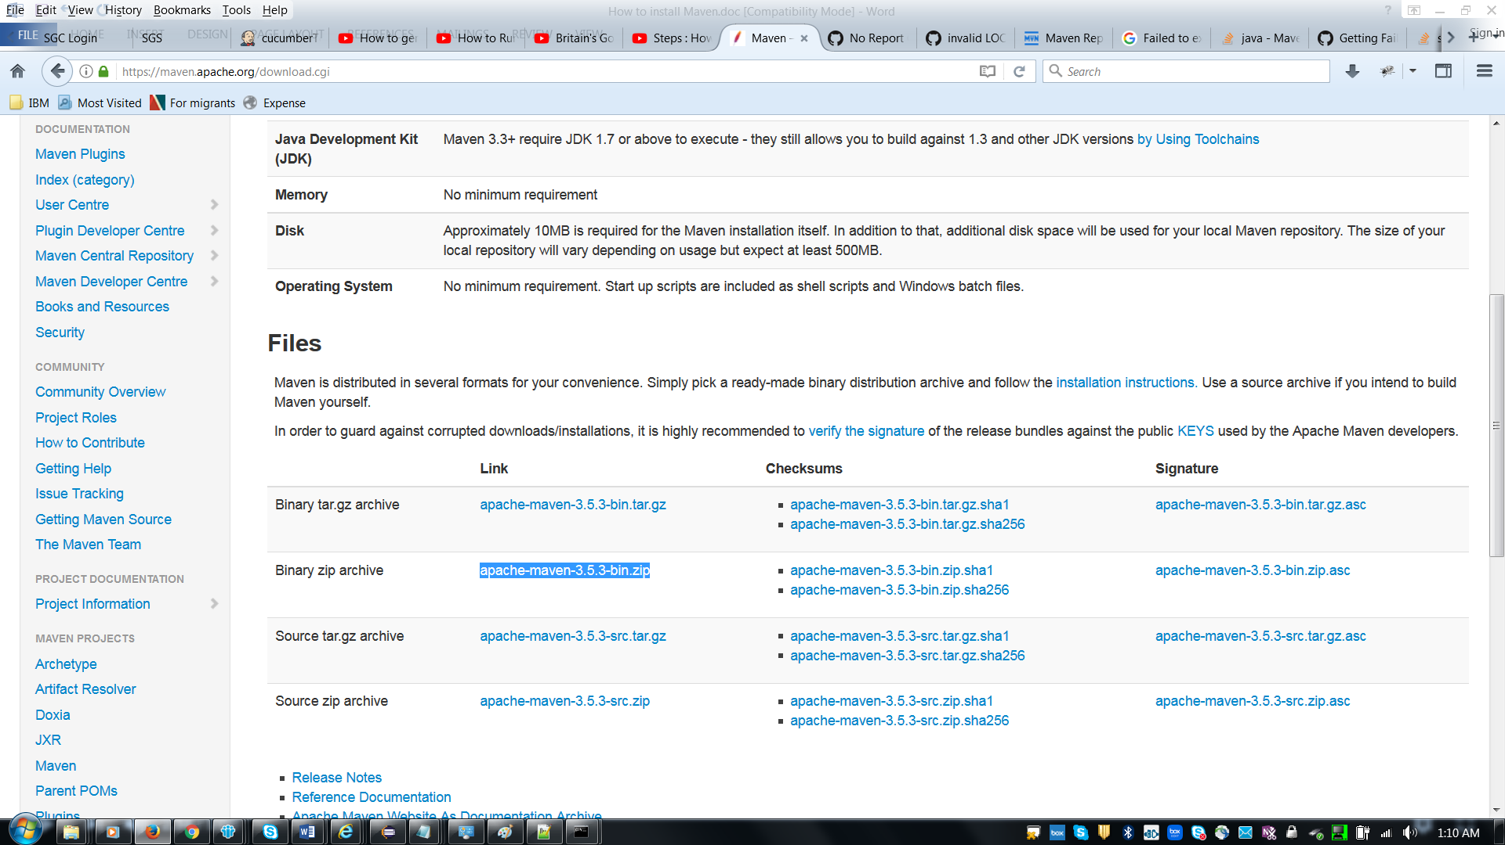

C:\Users\IBM_ADMIN\Documents\L420 Backup\AirBus\Maven\apache-maven-3.5.3-bin\apache-maven-3.5.3\bin;

- Copy the zip file at any location and extract it.
Example : Suppose we have kept file at below location.
C:\Users\IBM_ADMIN\Documents\L420 Backup\AirBus\Maven\
- Now take the path of Apache-maven-3.5.3 bin and copy into System environment “Path” variable.
BIN location : C:\Users\IBM_ADMIN\Documents\L420 Backup\AirBus\Maven\apache-maven-3.5.3-bin\apache-maven-3.5.3\bin;

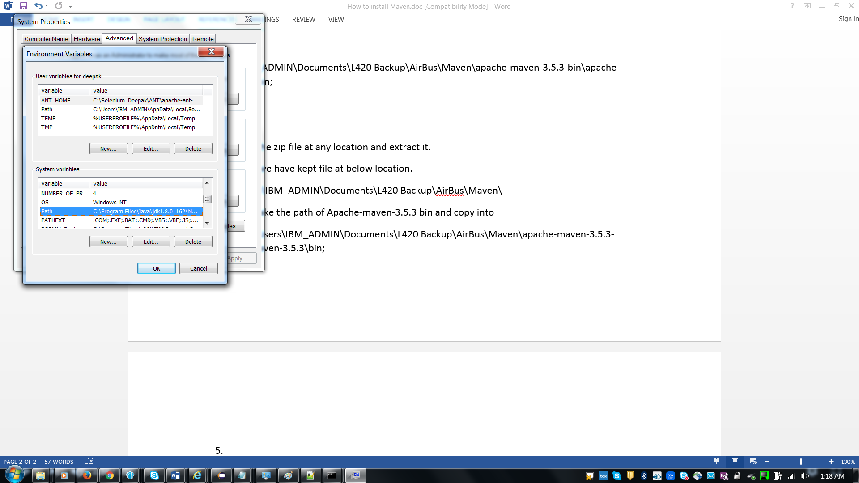

Note : If path variable is already available under system variable then click on edit button and paste the apache maven bin location using ; prefix.
Example: ; C:\Users\IBM_ADMIN\Documents\L420 Backup\AirBus\Maven\apache-maven-3.5.3-bin\apache-maven-3.5.3\bin;

- Go to command prompt and enter mvn –version to ensure maven is property installed.

